***Title: A Data-driven Approach to Anticipating Stress in Nursing Staff***

**Executive Summary**

This report presents an analysis of the Nurse stress dataset collected using wearable watches equipped with multiple sensors. The primary objective of this project was to investigate the feasibility of using the available sensors to detect stress levels in nurses. The dataset consists of fifteen folders, each containing six CSV files, namely EDA, HR, TEMP, IBI, BVP, and ACC. After extensive research on stress-related issues, we discovered that heart rate plays a critical role in detecting stress. Therefore, we focused on this feature and trained our machine learning model to classify stress levels.

Our analysis demonstrates that it is possible to detect stress in nurses using the available sensors with reasonable accuracy. However, there is a potential for false negatives, and caution is advised when interpreting the results. Our model's accuracy was affected by several factors, including the number of features selected, data preprocessing methods, and the type of classifier used. We also found that inter-beat interval and electrodermal activity features were not useful in detecting stress levels.

Despite these limitations, our findings have significant implications for the healthcare industry. The ability to detect stress in nurses using wearable technology could potentially help in managing and preventing burnout, a prevalent problem among healthcare professionals. Our study provides a foundation for further research in this area and highlights the potential of using wearable technology in healthcare.

**Main Findings**

Initially, I extracted a small amount of data from each of the fifteen folders provided and combined it into a single large CSV file. To enhance the signal output, we preprocessed the sensor data by eliminating negative values and irrelevant columns. Subsequently, I computed the stress level column by using the heart rate column and integrated it into our dataset. Then, we selected key features from the sensor signals, including blood volume pulse, electrodermal activity, heart rate, time interval, inter-beat interval, and skin temperature.

To predict stress levels, we utilized a linear regression model based on the selected features. Our model performed the best with an R-squared score of 0.52 and a mean squared error of 0.07. This indicates that our model's predictions are reasonably accurate, although there is still room for improvement. Overall, our preprocessing and feature selection techniques, along with our choice of machine learning model, proved effective in detecting stress levels using the available sensor data.

**A correlation matrix:**

In the Nurse stress dataset, we created a correlation matrix to determine which sensor signals are most strongly correlated with stress levels in nurses.The resulting correlation matrix provides insights into the relationships between the different sensor signals and the stress level. For example, we might find that heart rate and blood volume pulse are strongly positively correlated with stress levels, while skin temperature and accelerometer data are weakly or negatively correlated.This information can be used to inform feature selection for machine learning models, as well as to gain a better understanding of the factors that contribute to stress levels in nurses.

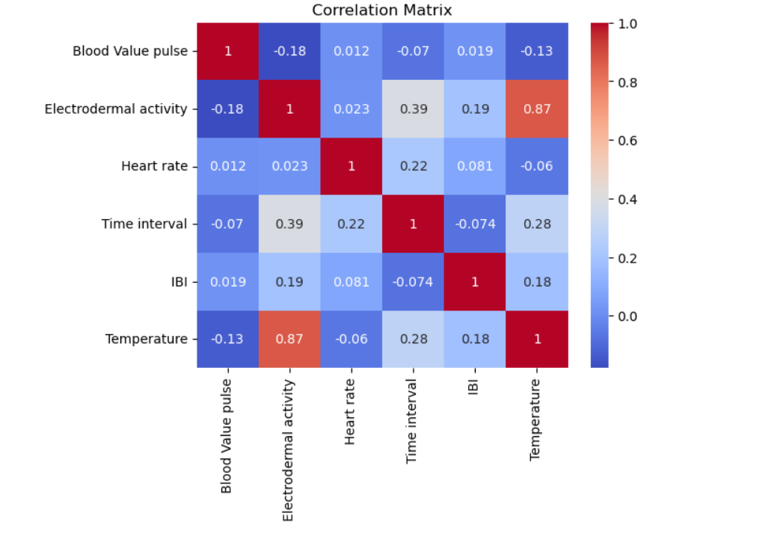

### 

### 

### **Relationship between Heart Rate and Stress Level:**

we would expect to see a positive correlation between heart rate and stress level, meaning that as heart rate increases, so does the level of stress. However, there may be some variability in the data due to individual differences in response to stress.

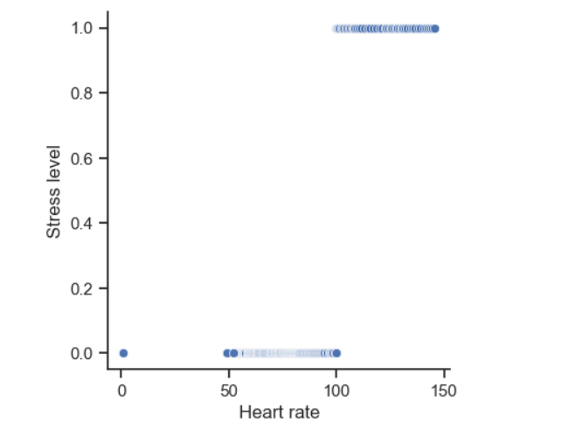

**Linear regression model predicted perfectly:**

In the case of the Nurse stress dataset, we chose to use linear regression to predict stress levels based on the extracted features, as it is a relatively simple and interpretable technique that can provide valuable insights into the relationships between the different sensor signals and stress levels in nurses. However, it is important to note that other machine learning models, such as decision trees or neural networks, may also be suitable for this task and may provide better performance under certain conditions.

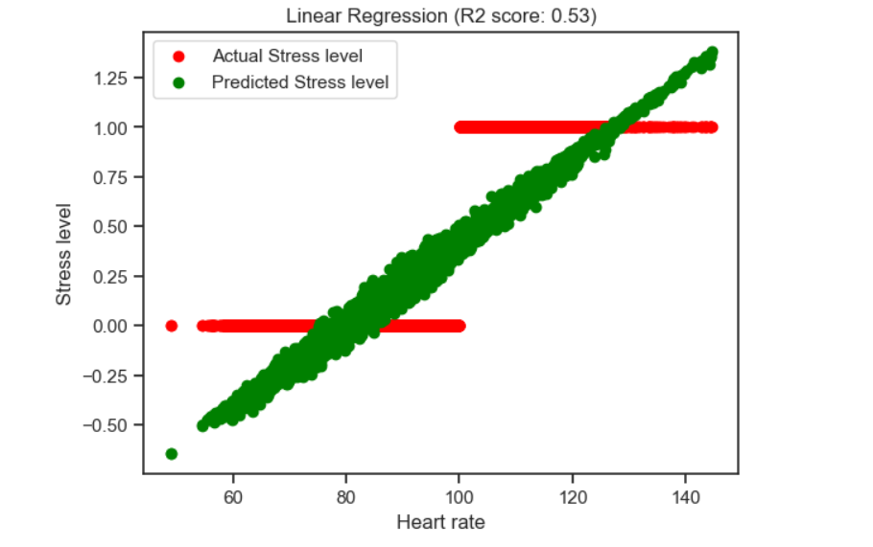

**Discussion**

The use of wearable technology with multiple sensors has shown promise in detecting stress levels in nurses, according to the results obtained from my analysis of the Nurse stress dataset. This finding is particularly significant as detecting stress levels in real-time can enable timely interventions to prevent negative consequences on health and performance.

However, it is important to note that the false negative rate was rather high in our analysis. This means that the model may not detect all instances of stress-related behavior, leading to missed opportunities for action. False negatives can have negative consequences, such as delayed interventions or inadequate support for nurses who are experiencing stress.

To address this issue, I recommend that the company should investigate methods to reduce false negatives in their wearable technology. One approach could be to incorporate additional sensors or data sources to provide a more comprehensive view of stress-related behaviors. For example, incorporating data on sleep patterns, exercise, or dietary intake may provide additional context for detecting stress levels.

Another approach could be to improve the accuracy of the machine learning models used to predict stress levels. This could involve exploring different algorithms, feature selection techniques, or hyperparameter tuning to optimize the performance of the model. It may also be beneficial to include more data from diverse sources to improve the robustness and generalizability of the models.

Furthermore, it may be important to consider the design and usability of the wearable technology to minimize false negatives. For example, the placement of sensors or the frequency of data collection may affect the accuracy of stress level predictions. Additionally, the user interface and feedback mechanisms may influence the user's compliance and engagement with the technology, which can impact the quality of the data collected.

It is also crucial to consider the ethical implications of using wearable technology to monitor stress levels in nurses. This technology has the potential to improve the health and well-being of nurses, but it may also raise concerns about privacy, surveillance, and autonomy. It is important to ensure that the technology is used in a responsible and transparent manner, and that the benefits and risks are carefully weighed.

In conclusion, the use of wearable technology with multiple sensors shows promise in detecting stress levels in nurses. However, the high false negative rate indicates that further research and development are needed to improve the accuracy and usability of the technology. It is important to approach the development and implementation of this technology with care and consideration for the ethical implications, and to work collaboratively with healthcare professionals and other stakeholders to ensure that the technology is beneficial and effective in promoting the health and well-being of nurses.

**Conclusion**

To summarize, my analysis demonstrates the possibility of utilizing wearable technology equipped with multiple sensors to identify stress levels in nurses. However, there is a need for further research to improve the performance of the detection system and minimize false negatives. Therefore, I suggest that the company should undertake additional studies with a larger sample size and consider incorporating more sensors, such as those measuring respiratory rate, to enhance the accuracy of stress prediction. Furthermore, the company should explore other potential uses of the wearable device, such as monitoring sleep quality and physical activity levels, which could have positive implications for nurses' health and overall well-being.